Code section result:

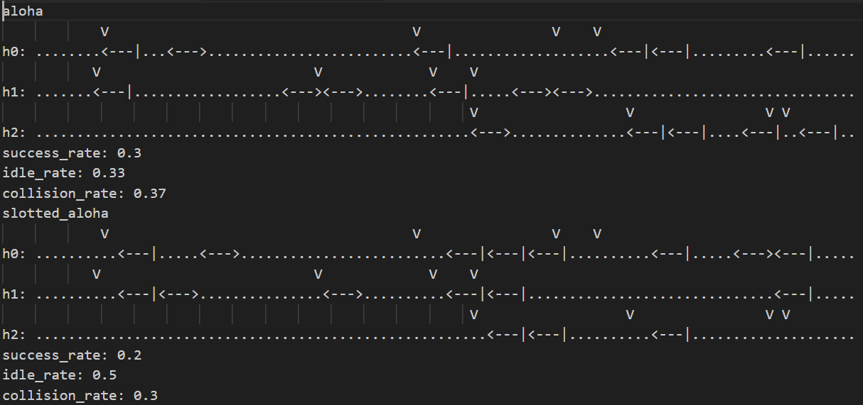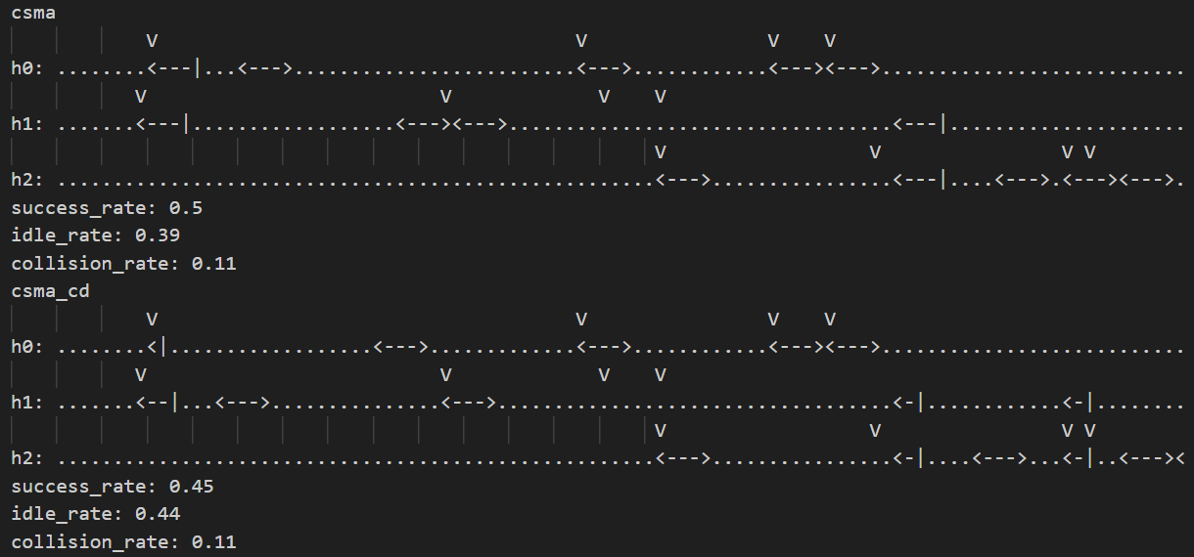

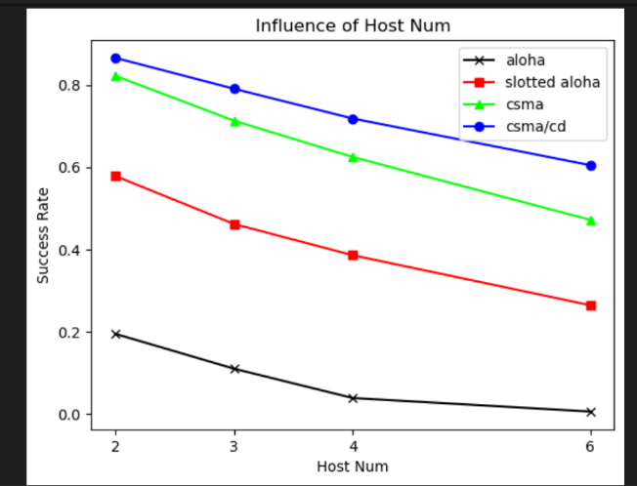 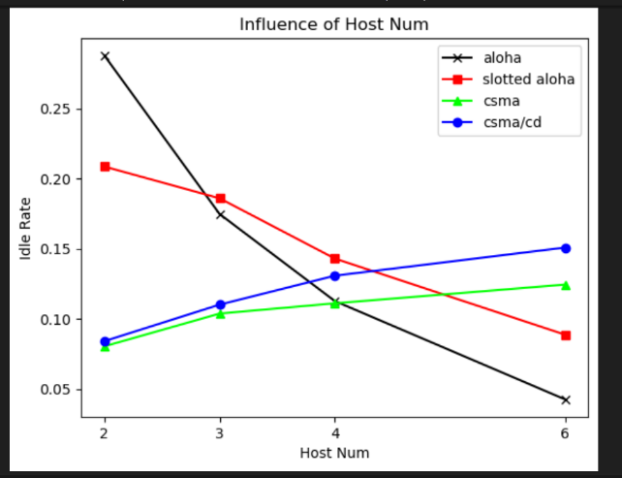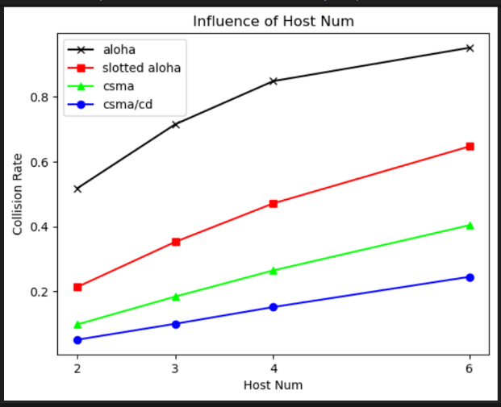

Question

1.



2.

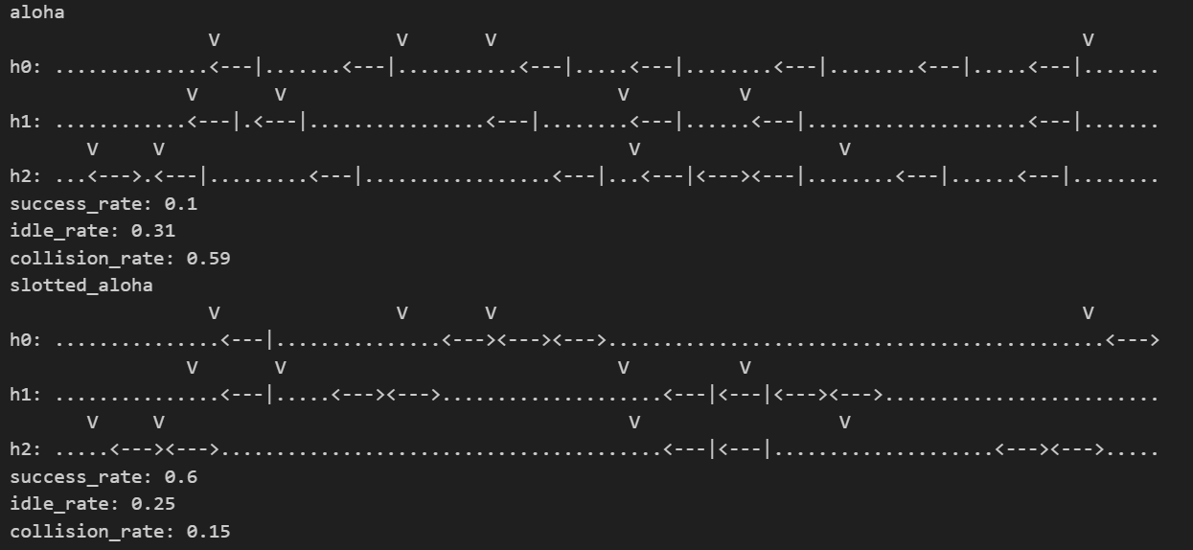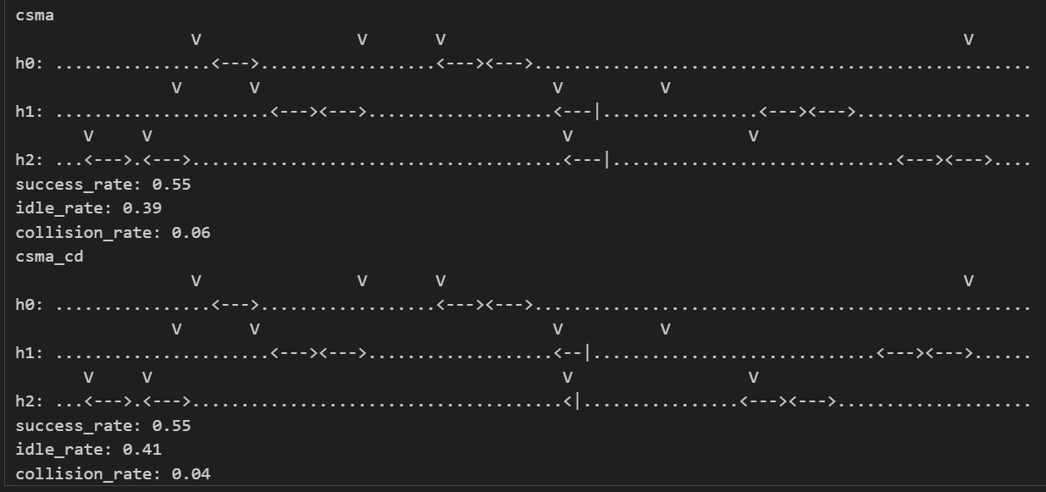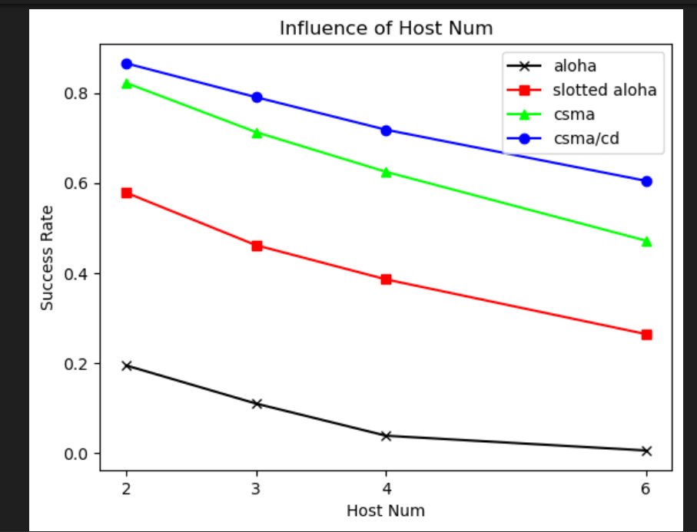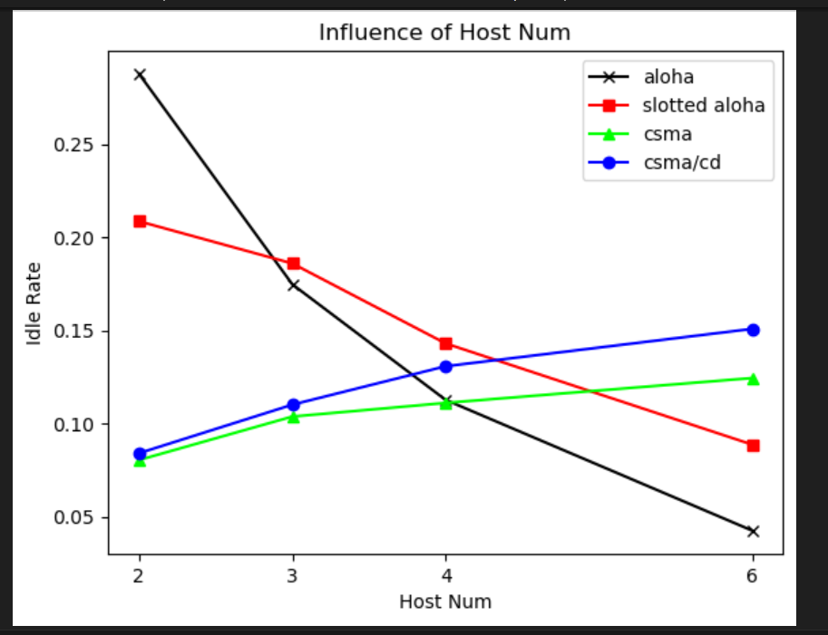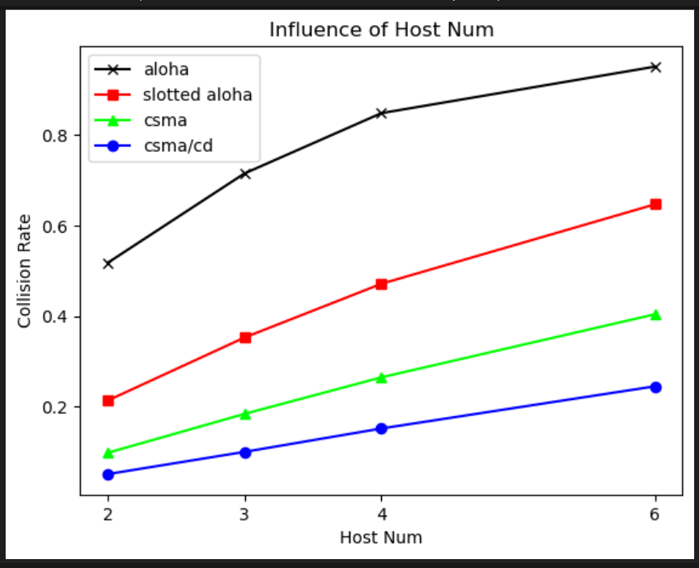

3. Comparing to setting in question 2, for max collision wait time, when number of host is 2, waiting time is smaller than 20, when host is 3, 4, 6 is greater than 20, therefore in both success rate and collision rate, 2 host is slightly worse while other is slightly better (more back off time).

For possibility of resend rate in slotted aloha, it is way lower when number of host is 3, 4, 6, therefore idle rate tends to be higher.

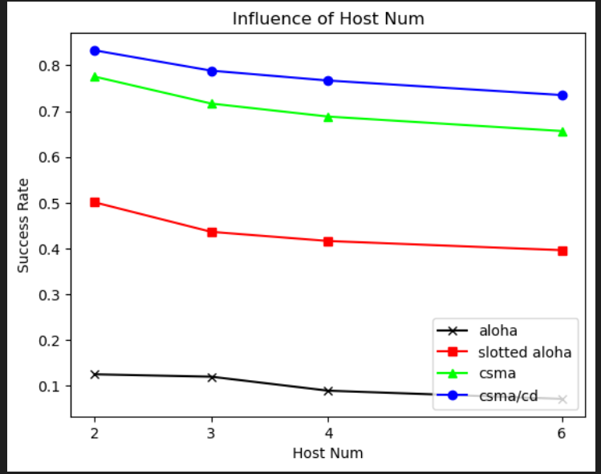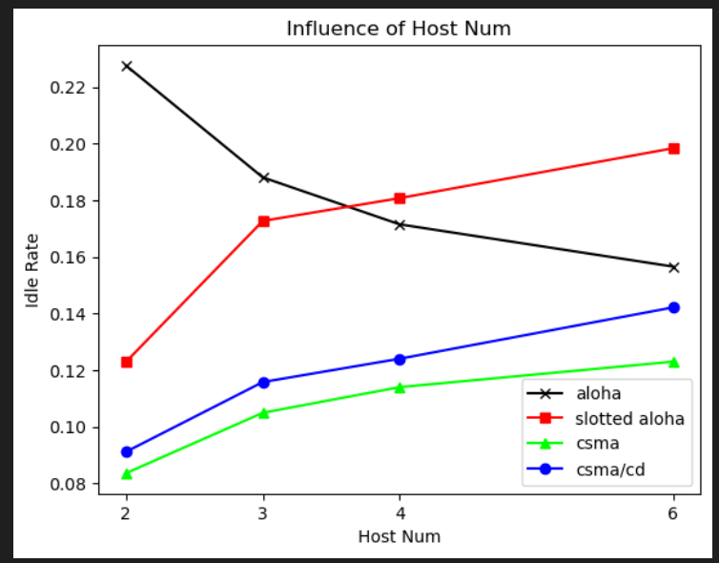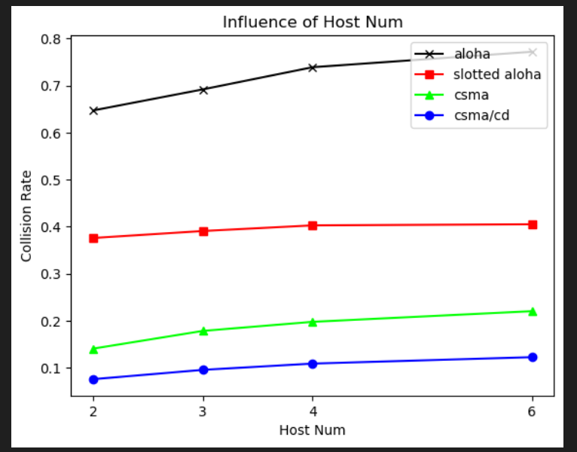

4.

Waiting time goes up when coefficient goes up, therefore the trend of every rate will become the same for high value coefficient due to high waiting time. Especially for collision rate.

For p_resend, it will become very low when coefficient grows, therefore idle rate for slotted aloha will become high in the end.

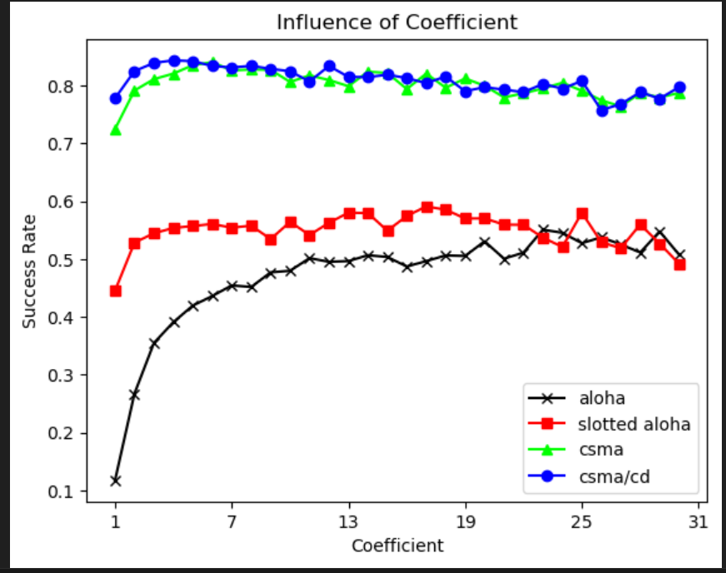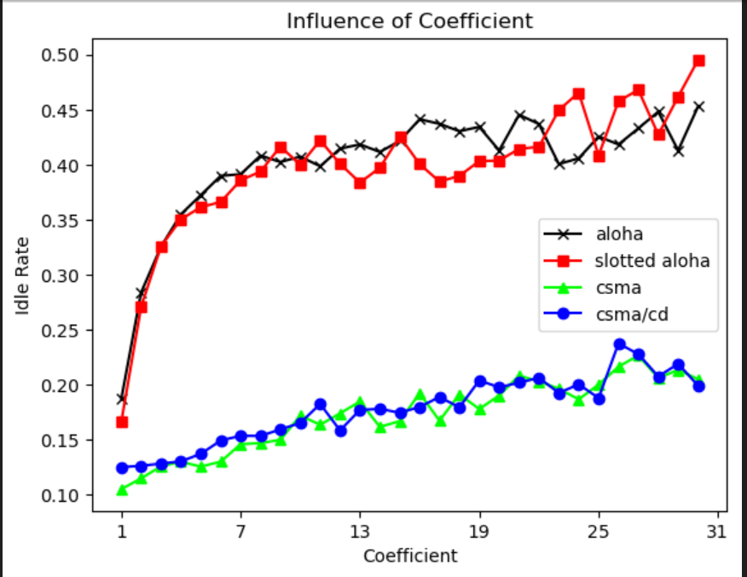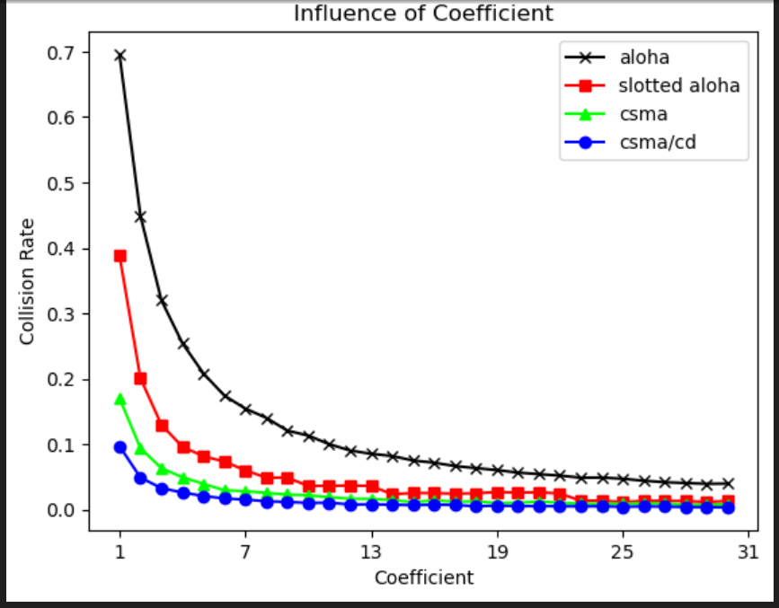

5. With number of packets increase, network will become more crowded, therefore idle rate decrease, success rate and collision rate increase.

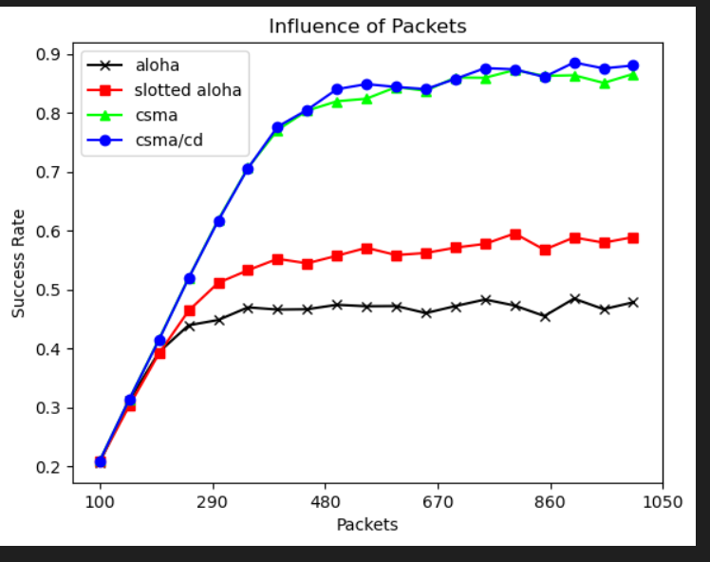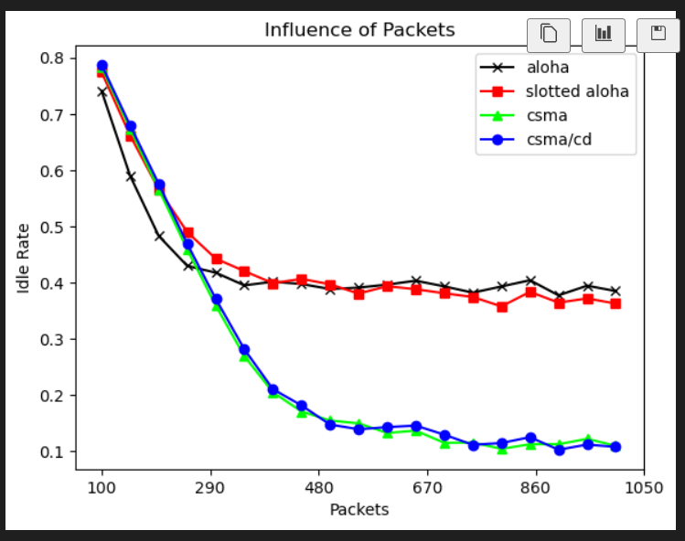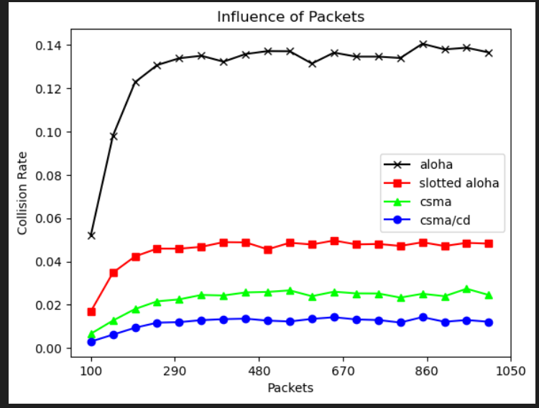

6. Increase number of hosts is almost like increase number of packets, which also makes network more crowded, therefore idle rate will decrease, success rate and collision rate increase.

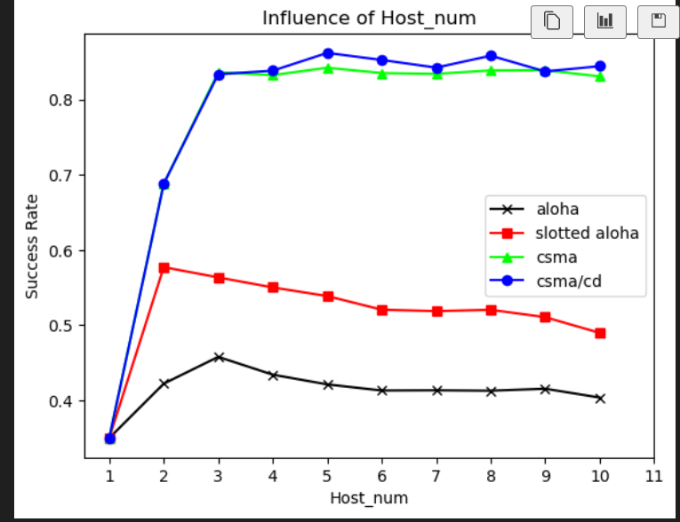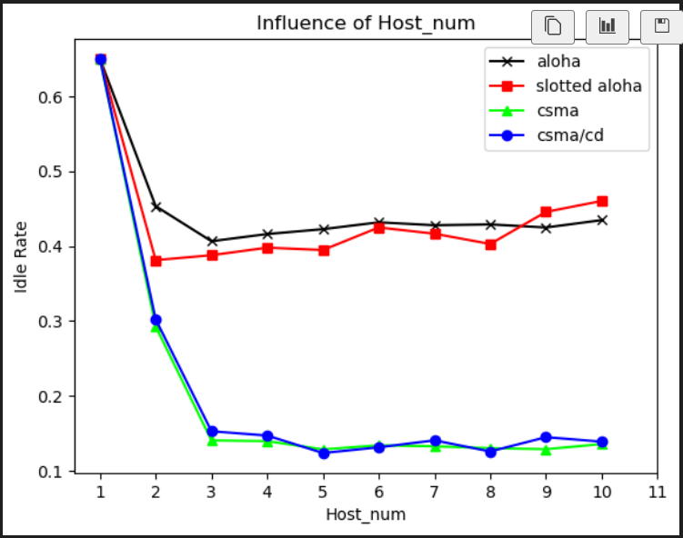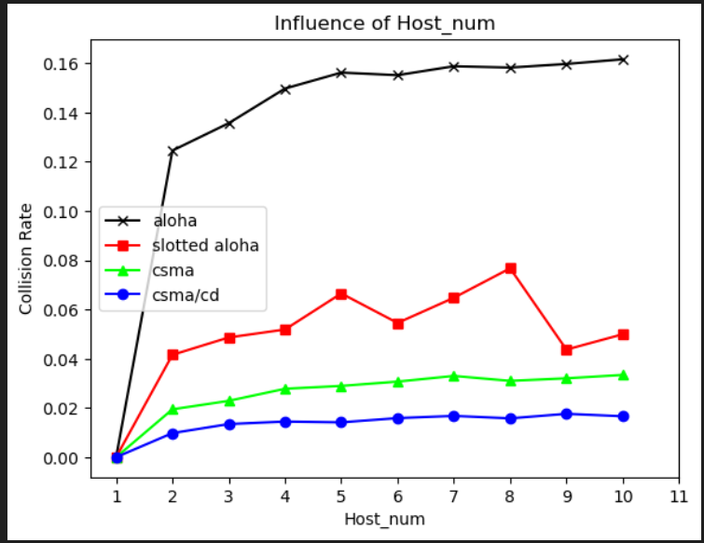

7. With packet size increase, transmit time will also increase, which can cause increase success rate, decrease idle rate. However, Aloha will therefore have more collision rate compares to csma csma/cd which can prevent collision.

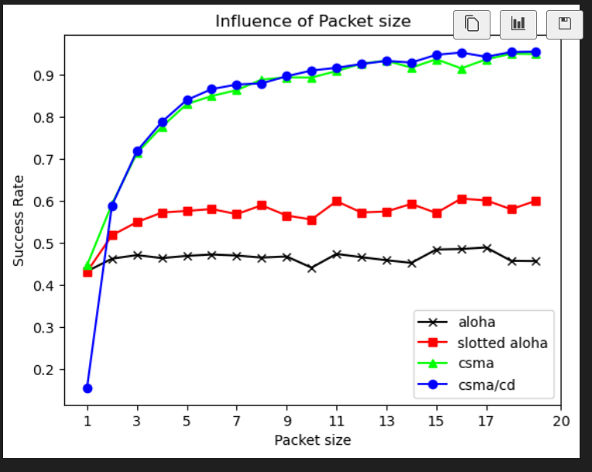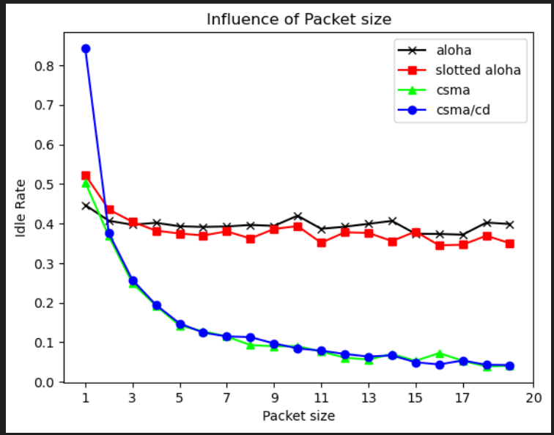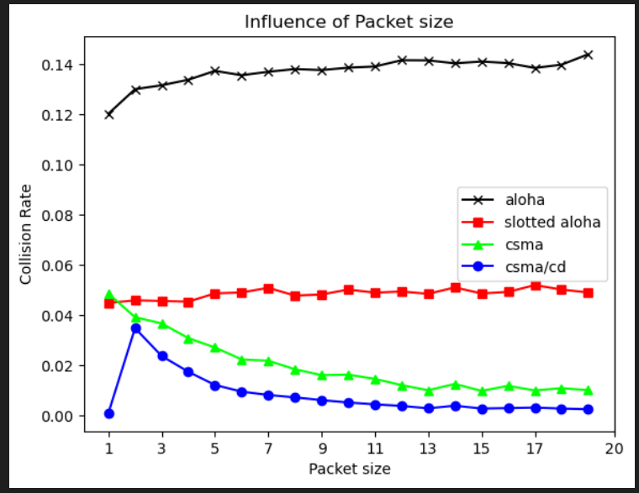

8. With more link delay, host may think there’s no transmitting packets and start sending packets, therefore causes collision, leads to decrease success rate, increase collision rate. And for csma/cd once collision happened, it will stop transmit and back off a random amount of time, causes idle rate increase.

